;l

Foundations of Programming

Assignment No. : 01
- PROBLEM STATEMENT:
Write a program in C to check whether a given year is a Leap Year

OBJECTIVE:

- To understand the use of conditional statements in C programming.
- To implement logical conditions for solving real-world problems.
- To develop problem-solving skills using decision control structures.

THEORY:
- Theory for conditional statements with syntax (if , if-else, if-else ladder) are used in C programming
- Theory for a Leap Year - year that contains 366 days instead of the usual 365 days.
Rules:
• A year is a leap year if it is divisible by 400, OR
• A year is a leap year if it is divisible by 4 but not divisible by 100.
- Algorithm
PLATFORM: Linux

INPUT: Enter a year (integer value).
CODE
#include <stdio.h>

int main() {
int a;
printf("Enter the year: ");
scanf("%d", &a);

if ((a % 4 == 0 && a % 100 != 0) || (a % 400 == 0)) {
printf("%d The year is a leap year", a);
} else {
printf("%d The year is not a leap year", a);
}

return 0;
}

OUTPUT: Displays whether the entered year is a Leap Year or Not a Leap Year.
Sample Input
2024
Sample Output
2024 is a Leap Year
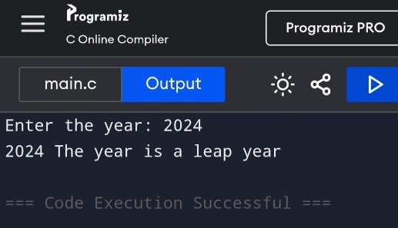

CONCLUSION: Thus, the program successfully checks whether a given year is a Leap Year using conditional statements in C.

FAQs:
- What is a leap year?
- Why is the year 1900 not a leap year but 2000 is?
- Which operators are used in this program?
- Difference between if and if–else statements.

